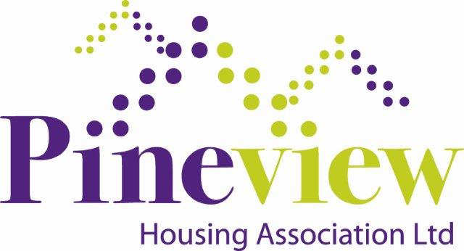
Heads of Ayr Farm
Park!

This year our Resident Forum invite you to enjoy a FREE Day Trip to Heads of Ayr Farm Park

The Association will cover the costs for transport & park entry. We will provide a healthy snack on the bus and you should either bring your own packed lunch or money to purchase your lunch in the café.
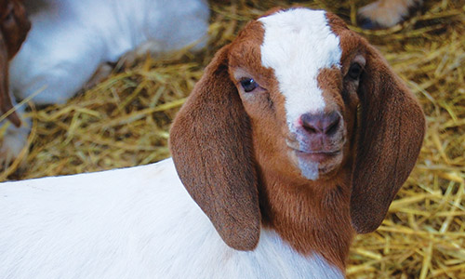

If you are interested in being part of what we hope will be a great day, please fill in the slip below and return to the office by Wednesday 10th July 2019. Places will be allocated firstly to residents and their household members, extended family members will be accommodated where possible, e.g. grandchildren. If you would like more information about the day, please call the office 0141 944 3891 and speak to Isobel or Mandy.

-------------------------------------------------------------------------------------------------------------------------------
I would like to attend the outing to Heads of Ayr Farm Park on Friday 09 August 2019.

Name: ___________________________________________________
Address: ___________________________________________________
Name of Children:
Age of Children: ___________________________________________________
(If applicable) ___________________________________________________
___________________________________________________
___________________________________________________
Telephone Number: ___________________________________________________

Email Address: ___________________________________________________
Information on how we handle and use your personal information that you provide to us is included within our Transparency Statement, copies of which can be obtained at the office.

